VISIONPICK CAPSTONE REPORT

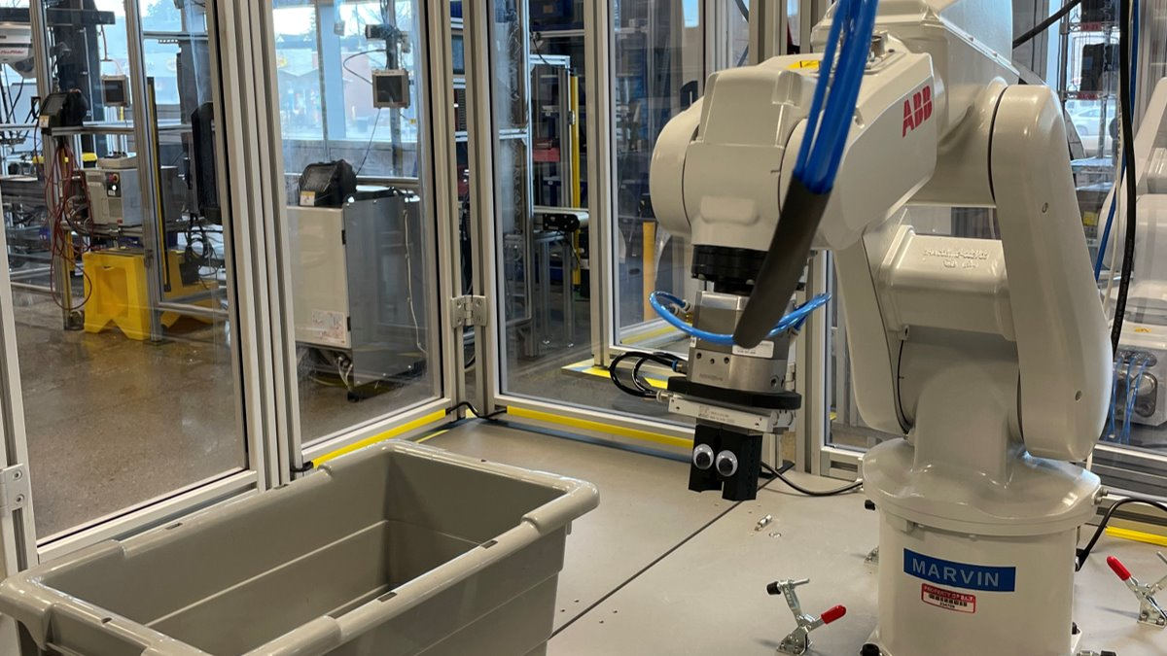

Prepared by:
Jose Alemany Hernandez
Nick Chau
Sayeh Fazel Tehrannejad
Mason Yee
Program: Mechanical Engineering Technology - Automation
Institution: SAIT (Southern Alberta Institute of Technology)

Vision Pick Technical Report
Submitted to: Bruce
Submitted by: Jose, Nick, Sayeh, Mason
Client / Sponsor: Chris Dick
Course: PROJ
Institution: SAIT
Submission date: [March 13, 2026]

Dear Mr. Chris Dick,
The following report has been prepared in support of the work done by the Vision Pick Team and based on the contract we agreed upon, on January 23rd, 2026. Our team agreed to design, implement, and demonstrate a vision guided robotic bin picking mechanism within a work cell. The system will be able to identify randomly oriented circuit breakers in a bin and pick them up and place them onto the DIN rail with no human interference.
We would like to thank you for giving us the opportunity to work on this project, and your help along the way. The Vision Pick Project helped all the members of this team develop their skills and even gain new skills such as circuit diagram design, working with a vision system, and much more. It is important to mention that this project wouldn't have been possible without the help of our technical instructors (Daniel Barrett and Simon St Jean), our communication instructor (Bruce Watson) and SAIT automation labs and facilities.

Sincerely,
Jose Alemany Hernandez
Nick Chau
Sayeh Fazel Tehrannejad
Mason Yee

Executive Summary

Vision Pick is a capstone project focused on solving a common manufacturing challenge: reliably handling and placing small parts with high precision and consistency without relying on manual labor. The problem is that circuit breakers are randomly oriented in a bin, and picking/placing them by hand (or with poorly designed automation) can be slow, inconsistent, and can cause placement errors or equipment issues.
The proposed solution is a vision-guided robotic work cell that detects the circuit breakers in a bin, selects a valid pick, and uses a robot with an end effector to pick the part and place it accurately onto a DIN rail, while a controls system (PLC/IO and safety interlocks) coordinates the sequence and ensures safe operation. At this point, the project is integrated as a full system—work cell layout, vision setup and calibration, robot/EOAT, and controller’s logic (programming stage)—moving towards a complete demonstration of fully automated bin picking. Key results include establishing the system architecture and integration approach, with ongoing validation by testing reliability, repeatability, accuracy, and efficient cycle time.

Executive Summary 4
Table of Figures 6
Table of tables 6
1. Introduction 8
1.1 Objective 8
1.2 Background 8
1.3 Problem Statement 8
1.4 Project Scope 9
1.5 Design Constraints 10
2. System Design 11
2.1 Work Cell Layout 11
2.1.1 Camera 11
2.1.2 Bin positioning 12
2.1.3 Power Supply 12
2.1.4 DIN Rail Placement 12
2.1.5 Lighting 13
2.2 Vision System 14
2.2.1 Camera specifications 14
2.2.2 Software 14
2.2.3 Electrical Connection 14
2.2.4 Vision Assistant 16
2.3 Robot Arm: 16
2.3.1 IRB 120 16
2.3.2 Robot Specifications 16
2.3.3 Controller 16
2.4 End effector/gripper 17
2.4.1 Factor of Safety Analysis 17
3. Integration 19
3.1 Camera 19
3.1.1 Calibration 19
3.1.2 Models 23
3.1.3 Logic and interfaces 25
3.2 The integration of camera and robot 26
3.3 The robot programming 26
3.4 Additional information on the project 30
4. Conclusion 31
Bibliography 32
Appendices 33
Robot additional information: 33
Client agreement 34
Management 37
Relevant findings 37
Discussions 37
Safety assessment 37

Table of Figures
Figure 1 DIN rail and circuit breaker placement 9
Figure 2 FOV calculator 11
Figure 3 Camera holder design 12
Figure 4 work-cell layout 13
Figure 5 Electrical diagram 15
Figure 6: IRB 120 [1] 16
Figure 7 IRC5C controller [4] 17
Figure 8 3D printed gripper 17
Figure 9 simulation for grippers 18
Figure 10 simulation for camera holder 19
Figure 11 IFM Vision Assistant 20
Figure 12 IFM application tab 20
Figure 13 IFM calibration tab 21
Figure 14 IFM calibration sheet 21
Figure 15 IFM robot coordinates tab 22
Figure 16 Marker sheet rotation examples 22
Figure 17 IFM Z offset calibration 23
Figure 18 Anchored contour 24
Figure 19 The Blobs analysis 25
Figure 20 Interface 26
Figure 21 Robot's working range 33
Figure 22 Robot specification 33
Figure 23 Client agreement 34
Figure 24 Milestones and due dates 35
Figure 25 Signatures 36

Table of tables
Table 1 Electrical equipment list 13

Introduction
This report presents the design and development of a vision-guided robotic pick and place system for identifying circuit breakers at a random orientation in a bin and placing them effectively onto a DIN rail using a 2D camera.

1.1 Objective
The Purpose of this technical report is to provide the client and instructors with a clear record of the design integration, and development of the vision guided pick and place system. It presents the technical information required to assess the project’s design decisions, and overall effectiveness in considering the specified objectives and constraints. By documenting the research, specification of the components selected, system integration, and implementation process, the report addresses the audience’s need for a structured and technical explanation of the proposed solution and possible alternatives.

1.2 Background
Modern manufacturing relies heavily on automated processes to improve productivity and efficiency, and even lower costs. Automation is expected to expand more in the future. A task that remains challenging is bin picking, where parts are placed randomly into a container and later transported. Traditional automation systems often struggle with this type of application because the exact location of a part must be known before it can be picked successfully. Although this issue can be addressed using alignment mechanisms, doing so adds complexity to the system and sometimes the need for big work areas just to be able to process a part. To solve this problem, machine vision can be used to detect position and orientation of parts and transfer that information to the robot for the pick operation. In the Vision Pick project, this concept is applied on circuit breakers that must be identified in a bin and placed accurately onto a DIN rail.

1.3 Problem Statement
The manufacturing industry is extremely dependent on automated systems to handle small objects with a high level of precision consistently. The client requires a vision-guided robotic system that can identify circuit breakers in a bin, pick them up reliably, and place them accurately onto a DIN rail. This problem is important because manual handling can be inefficient, pricey, and inconsistent, while wrongly executed automation can result in placement errors, equipment damage, or unsafe operations.

1.4 Project Scope
The scope of the project is to design, implement, and demonstrate a vision-guided robotic bin picking mechanism within a work cell. The system will be able to identify randomly oriented circuit breakers in a bin and pick them up and place them onto the DIN rail with no human interference.
The above statement is taken from the client agreement and outlines the scope of work we agreed upon by our team and our client, Mr. Chris Dick. Based on this agreement, the project team is responsible for integrating the vision camera with the robotic system. This includes designing the required circuit for the camera connection, programming the camera, programming the robot, and ensuring proper communication and coordination between two systems.
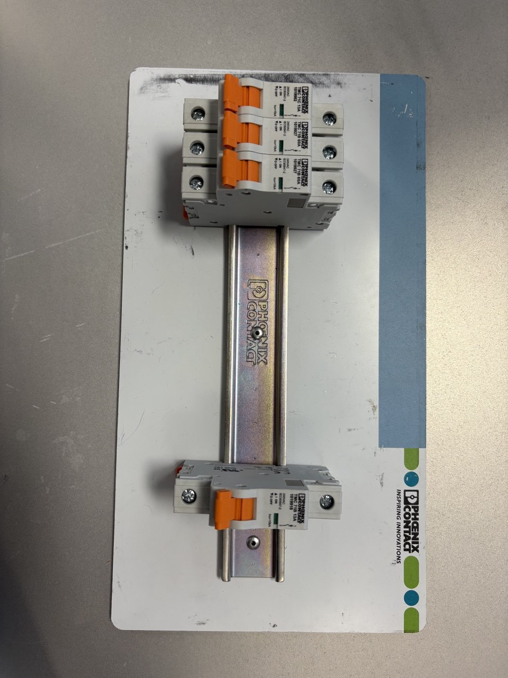
Figure 1 DIN rail and circuit breaker placement

1.5 Design Constraints
The following constraints were considered throughout the completion of the project:
- Placement precision: circuit breakers must be placed onto the DIN rail with consistent alignment and positional accuracy.
- Cycle time: the project team was not given a specific constraint regarding cycle time; however, a shorter cycle time was preferred by the client as it could improve the overall efficiency of the system.
- Safety requirements: The project must follow the laboratory safety standards required by the Government of Alberta during all stages.
- Hardware limitations: design choices must remain within the available lab equipment and robot payload limits.
In addition to the constraints listed above, the system must operate reliably for multiple cycles, and all components are expected to work together seamlessly within the work cell. Variations in lighting must be considered since the detection process is heavily dependent on the light conditions. The camera must therefore be programmed to compensate for changes in lighting to maintain accurate detection.

System Design
This section of the report will cover the overall operation of the Vision Pick system, including the hardware and software components used in the project, as well as their relations while they integrate during the operation. For this purpose, we have divided the section into smaller components for a better and easier understanding of the overall system.

2.1 Work Cell Layout
In automation labs, a work cell is usually utilized to prevent personnel and external objects from entering the operating range of the robot arm. This improves safety as industrial robots can cause significant hazards when operating at full speed during automatic operations. In the SAIT automation laboratories, these work cells are commonly constructed using aluminum extrusion frames.
For the Vision Pick project, the provided work cell was used to establish a consistent and repeatable system layout. Fixed positions were chosen for the robot, camera, circuit breaker bin, and DIN rail placement area so that the system could operate reliably during programming and testing. The layout was planned to ensure that the camera had a clear view of the bin; the robot could reach both the pickup and placement locations within its working envelope, and the components remained securely positioned throughout operation. Maintaining all components in the same location also improved calibration accuracy, reduced setup errors, and supported overall system consistency in case the project wants to be replicated in other work cells.
Important specifications taken into consideration for the positioning of the components were:

2.1.1 Camera
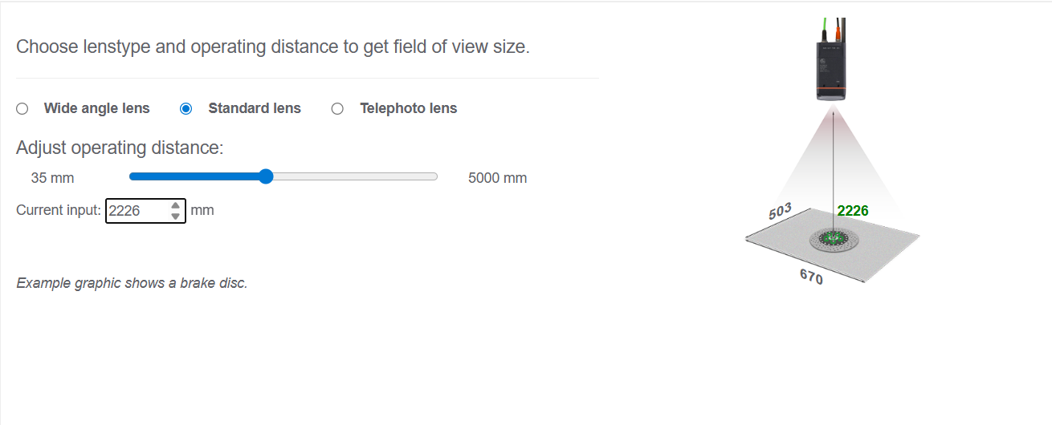
This camera comes with a standard lens that has a minimum operating distance of 85mm with this only having a 28 x 21 Field of View (FOV) and recommended maximum of 5000mm with a 1127mm x 1502mm. The camera was mounted on the aluminum extrusions in a downward facing orientation. A FOV calculator was used to find the perfect ROI (region of interest) of the provided O2U540 IFM Camera, that would allow for the camera to view the bin with breakers and a buffer station. The FOV calculator used was found on the IFM website. After measuring the inside dimensions of the bin, it was determined that to achieve the required field of view, the camera needs to be elevated above the height of the worksurface by 2226 mm plus 10%.
Figure 2 FOV calculator
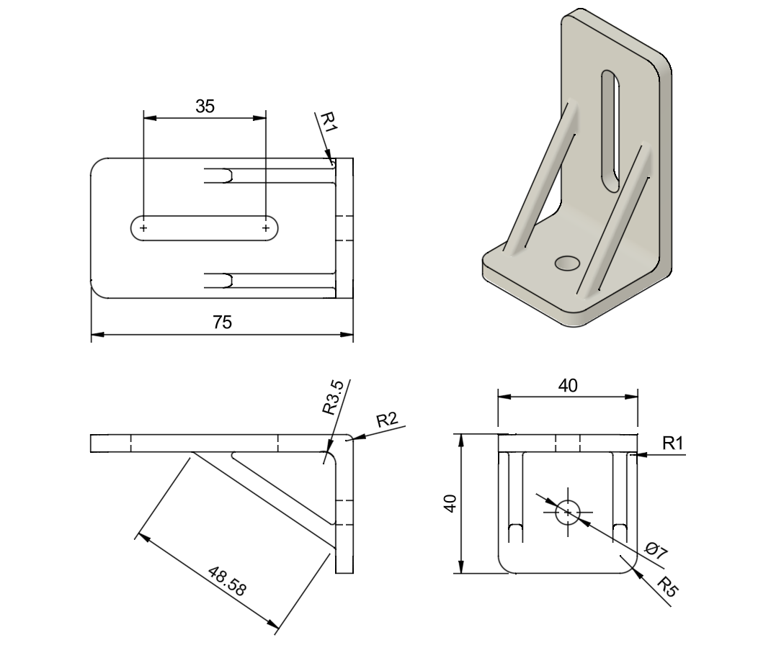
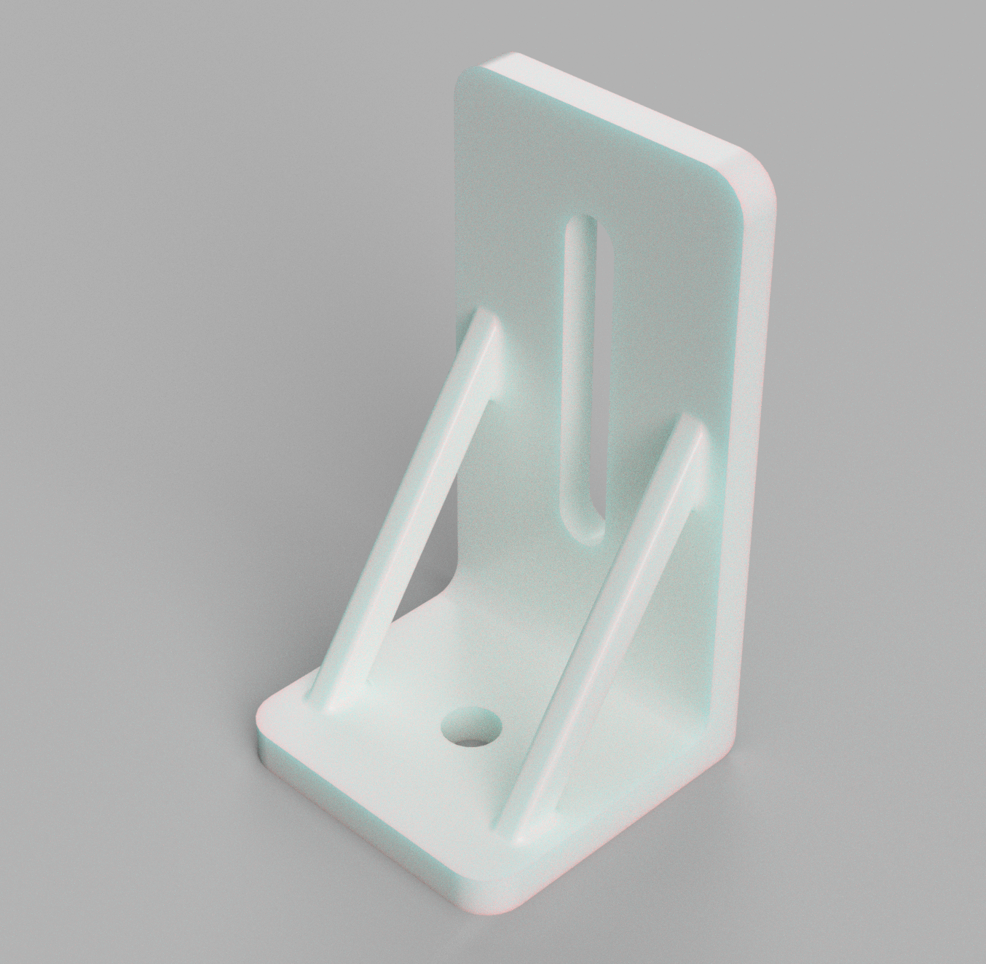
To address this, a T-shaped structure was constructed using aluminum extrusions. Positioning the camera at approximately 1.58m above the work cell. An IFM metal clamp with four screws was provided for mounting the sensor, it was not directly compatible with the selected extrusion arrangement. As a result, a custom clamp holder was designed and 3-D printed to secure the vision sensor to the aluminum extrusion at the top of the work surface.
Figure 3 Camera holder design
This mounting solution satisfied the height requirements, improved stability, and allowed the camera to be positioned correctly over the bin for reliable part detection, and more maneuverability. The calculated FOV that covered the area needed for this camera to analyze all the data is approximately 2473mm.

2.1.2 Bin positioning
The bin was placed directly underneath the camera for a clear view. The bin needed to be placed at a distance that was within the working envelope of the IRB120, not too close or far. To keep the bin in a consistent place, brackets were printed in 3D to be placed in opposing corners to keep it in place.

2.1.3 Power Supply
The power supply was required to be placed within the work cell with no external access to avoid incidents of bumping into it and damaging the equipment. The envelope of the robot was taken into consideration to avoid any case of damaging the camera in case the uncontrolled movement of the robot could be moved closer later once the system gets more refined to make it more compact.

2.1.4 DIN Rail Placement
The DIN rail was positioned in a place where the robot can easily have access to and place the rail without much effort. This was thought of for the reason of saving time on placing part of the system

2.1.5 Lighting
External lighting was needed due to how high the camera is, the built-in light cannot be as reliable as an external light source. The light sources were placed in a way that it can shine into the bin directly and not obstruct the camera view. The lights provided had a short cable which is why the two lights are close to each other.
Figure 4 work-cell layout

IRB 120

DIN rail

Bin
Camera
(above bin)

Lamp 2
Lamp 1

2.2 Vision System
The IFM O2U540 vision sensor provided for the project is used to detect circuit breakers located randomly inside the bin. The O2U540 is a high-performance 2D vision sensor designed to be a for industrial automation. It combines object recognition, code reading, and Optical Character Recognition (OCR).

2.2.1 Camera specifications
O2U540 has:
- RGBW lighting option.
- 2 Digital Outputs.
- Up to a 5-meter working distance.
- Connection via, TCP/IP, EtherNet/IP, PROFINET.

2.2.2 Software
- Windows 10 or Windows 11.
- Version 1.33.20 must be on the sensor.
- IFM Vision Assistant version 2.10.9 or higher.

2.2.3 Electrical Connection
To ensure a stable connection and prioritize device safety, the team opted to power the camera via a dedicated external power supply rather than connecting it directly to the robot controller. This configuration, specifically requested by the client, Mr. Chris Dick, minimizes risks associated with high-voltage fluctuations from the controller. The creation of a custom-developed circuit design to integrate this independent power source was constructed to protect the camera.
List of equipment needed for the connection of the IFM O2U540 camera
Parts | Description | # of parts
Power Supply | 24v 2.5A 60W | 1
Fuse | 1A | 1
Fuse holder | To hold the 1A fuse | 1
Wire | Different colors of 18-gauge wire | 6(colors), 5 feet per color
Circuit Breaker | Main disconnect; controls 120VAC feed to PSU (L&N) | 1
I/O DIN rail modules | Connects the I/Os | 6
Camera Cord | M12 5pin power cord | 1
Table 1 Electrical equipment list

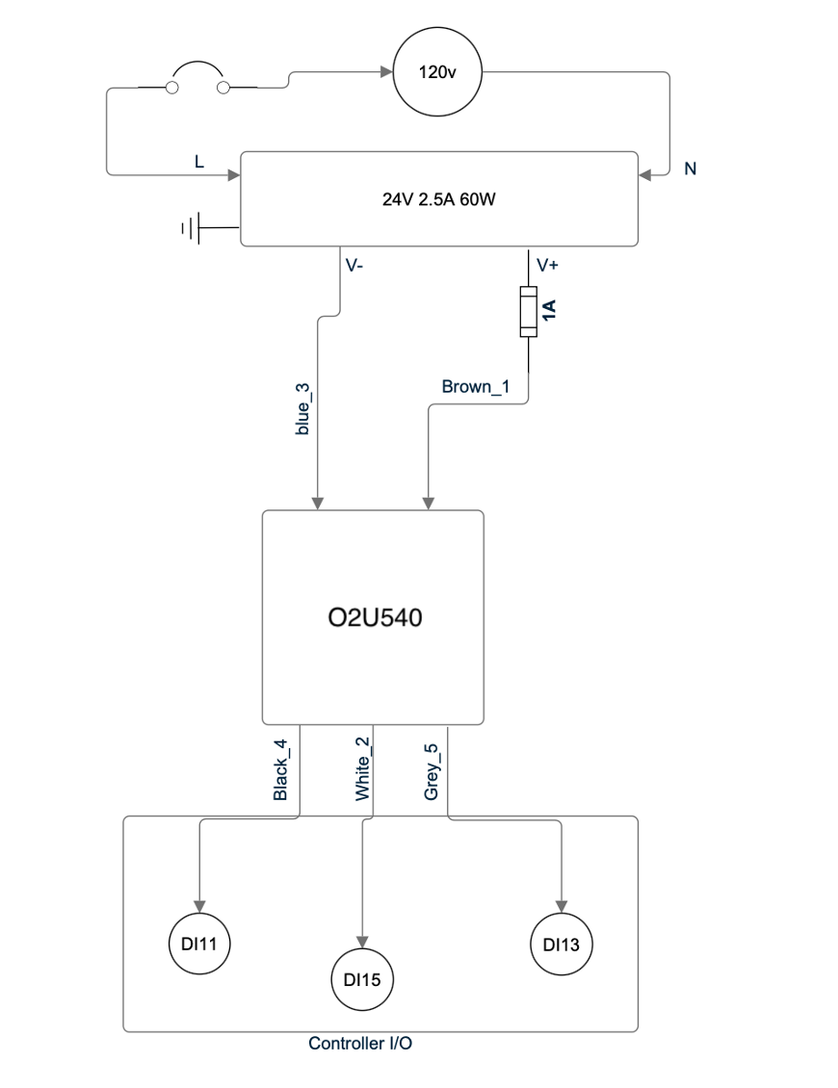
Figure 5 Electrical diagram

2.2.4 Vision Assistant
To code and get images from the camera it is required you download the IFM Vision Assistant which can be found at https://www.ifm.com/vn/en/product/O2U540#documents you will go to the bottom of the page and find the downloads tab and find the section titled “IFM Vison Assistant”, it will have multiple versions, download the most recent version, or at least 1.10.9. You will download a zip file, you will need to extract the file, afterwords you will find the IFMVisionAssistant application in the folder.

2.3 Robot Arm:

2.3.1 IRB 120
The IRB 120 is manufactured by ABB. This model has been discontinued by ABB; it remains one of their smallest robots in ABB’s lineup. The IRB 120 has a total weight of 23 kg and can be mounted in desired orientations, including on top of other machines or work surfaces. [1] [2]

2.3.2 Robot Specifications
The robot has six axes of motion and can handle a payload of up to 3kg. Its Aluminum body reduces the overall weight while maintaining structural strength. In addition, its compact motors provide the robot with the flexibility to move with both speed and precision. With a repeatability of 0.01mm, The IRB 120 is well suited for precise automation tasks such as pick and place operations. [3] [1]
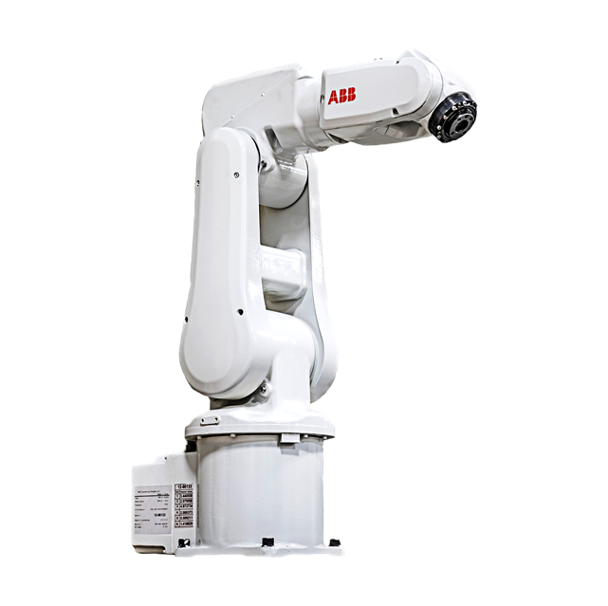
Figure 6: IRB 120 [1]

2.3.3 Controller
The IRC5C Compact controller is manufactured by ABB. The IRC5C is also 25% smaller than the original compact model with a height of 310 mm, width of 449 mm, and depth of 442 mm. This controller is equipped with a built-in 16 Input and 16 output I/O system. The Controllers act as the brain for the IRB 120. As robots do the physical aspect of the task, the controller makes the decision based on the program written on it. They also supply power to the system and exchange different I/O with the robot. [4]
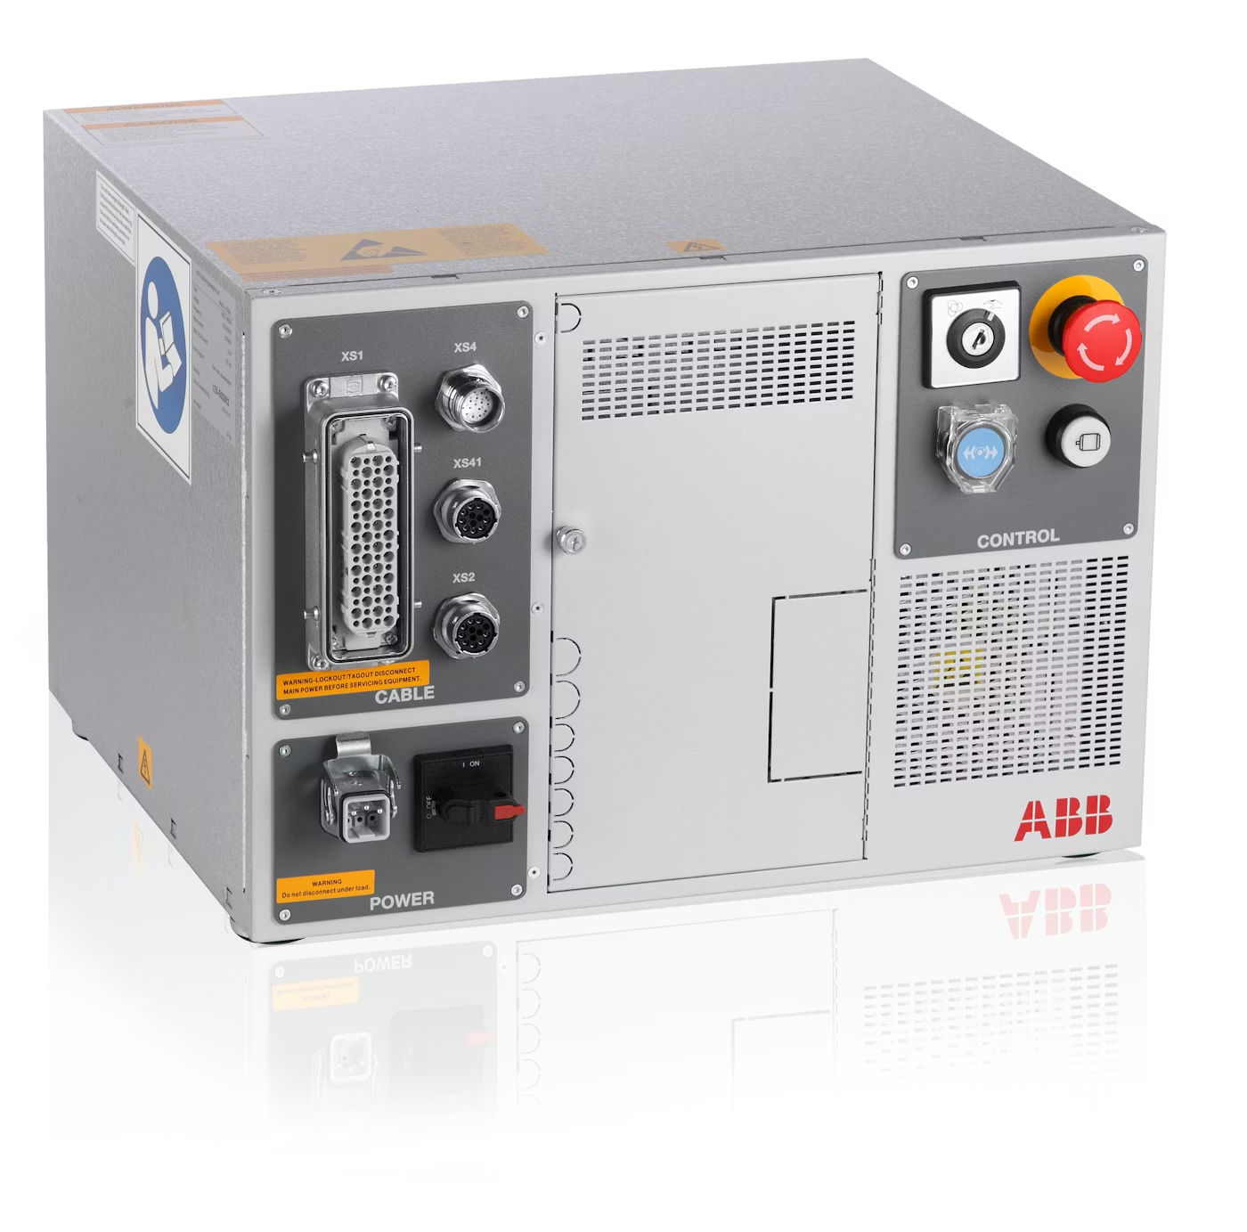
Figure 7 IRC5C controller [4]

2.4 End effector/gripper
After taking a closer look at our circuit breakers, it was decided to design a simple set of grippers with two levels allowing us to pick different parts of the breaker with the same end effector. The grippers are 3-D printed and modeled in SolidWorks. SolidWorks was also used for FEA analysis to make sure the grippers can handle the load of the circuit breaker and press them onto the DIN rail. The way these grippers were designed was by creating a stair style whereby having two different thicknesses would be able to pick the breakers in almost any position.

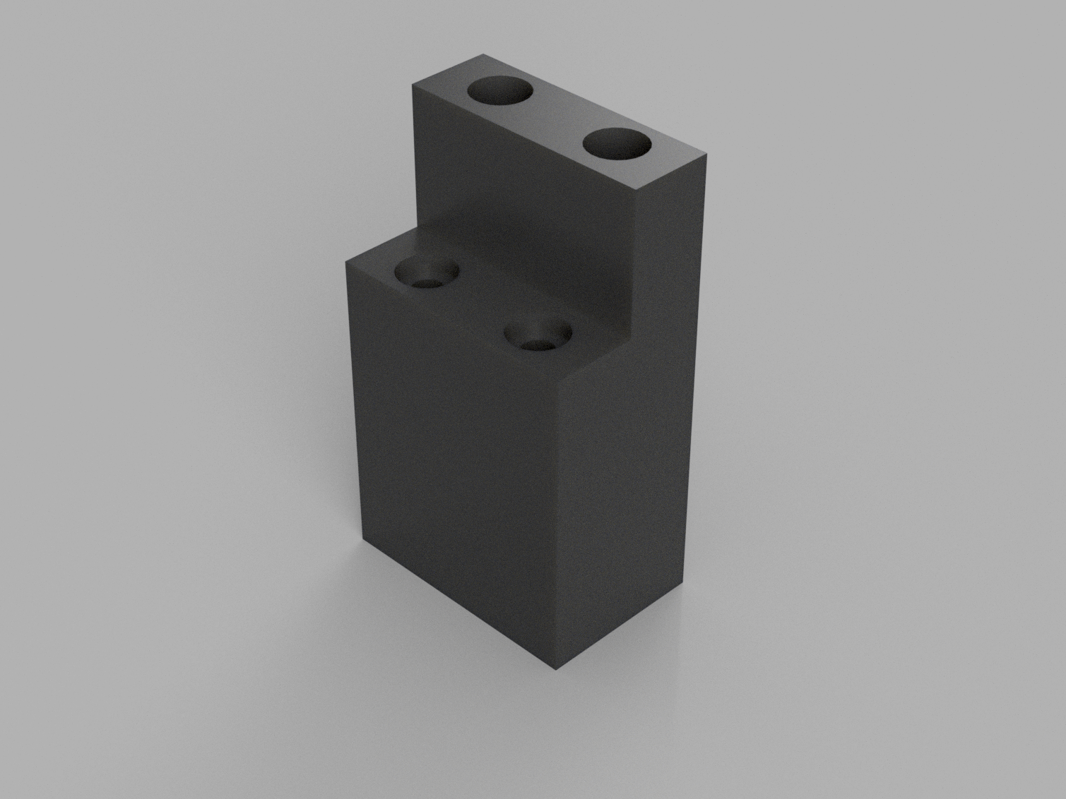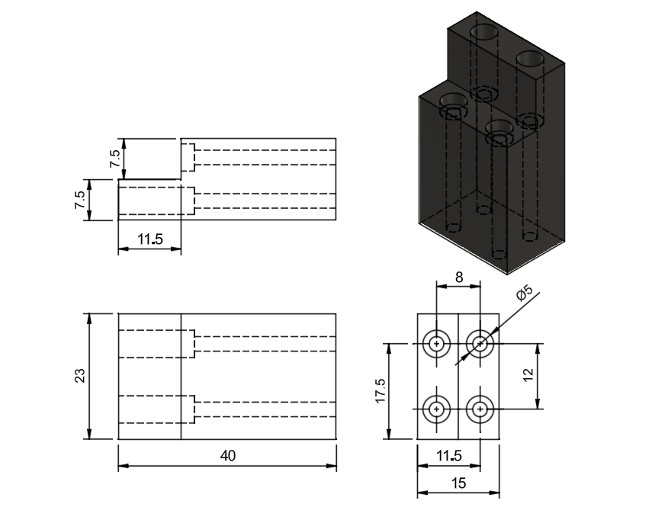
Figure 8 3D printed gripper

2.4.1 Factor of Safety Analysis
After finalizing our grippers design, an FEA was ran it through a test to figure out the safety factor. The first image was the simulation of the grippers pushing the circuit breaker down to lock it on DIN rail. The force required to do that is 50N, acting on an area of 17.5mm x 8mm, that gives a factor of safety of 24. The second image was the simulation of the grippers picking circuit breaker, the force was 3N acting on an area of 17.5mm x 17.5mm, that gives a factor of safety of 341. Both simulations showed that our grippers are safe for the operation.

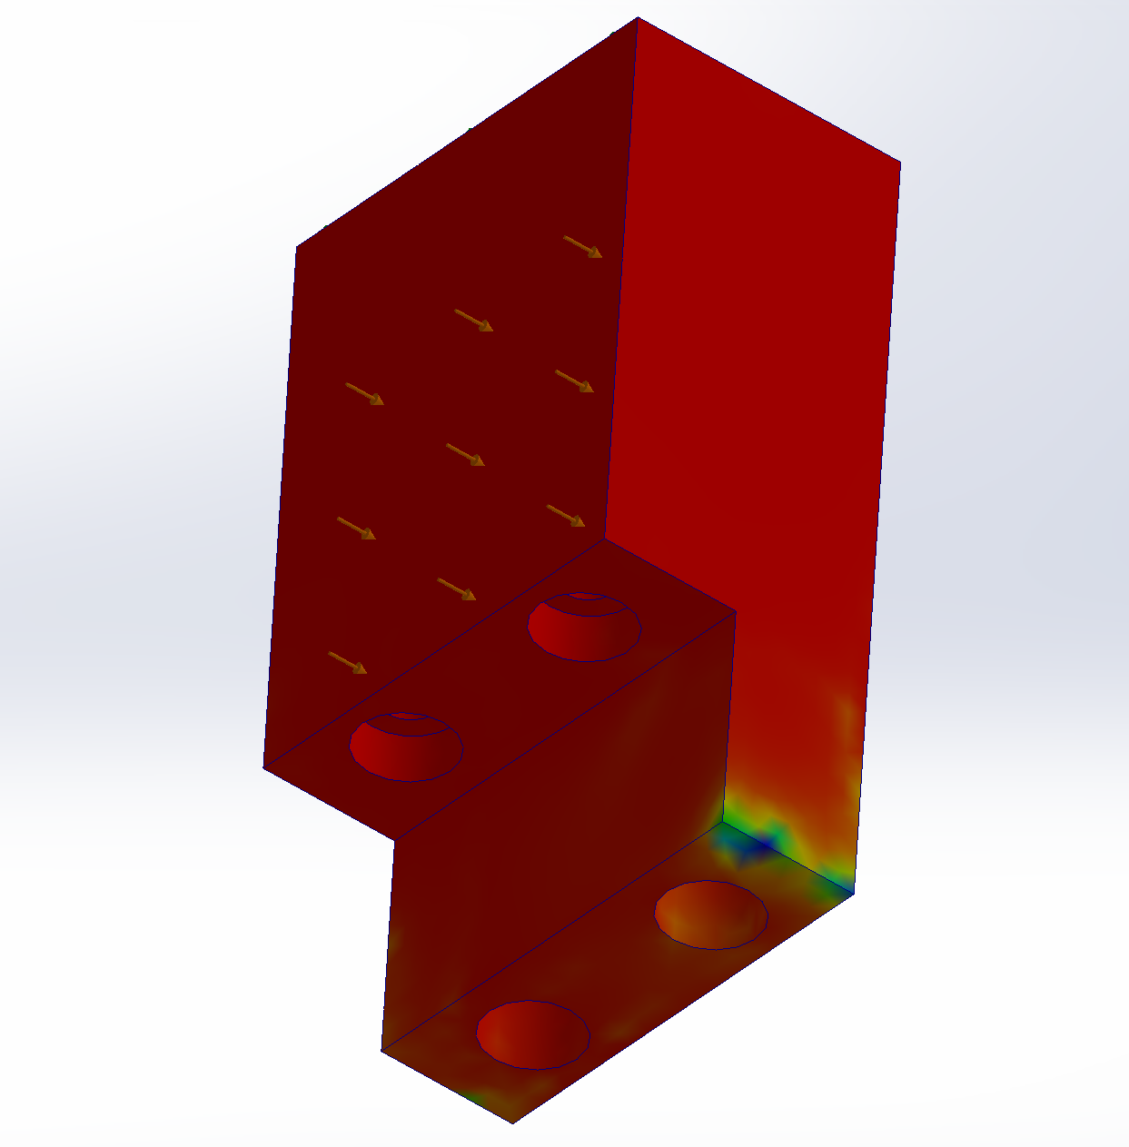
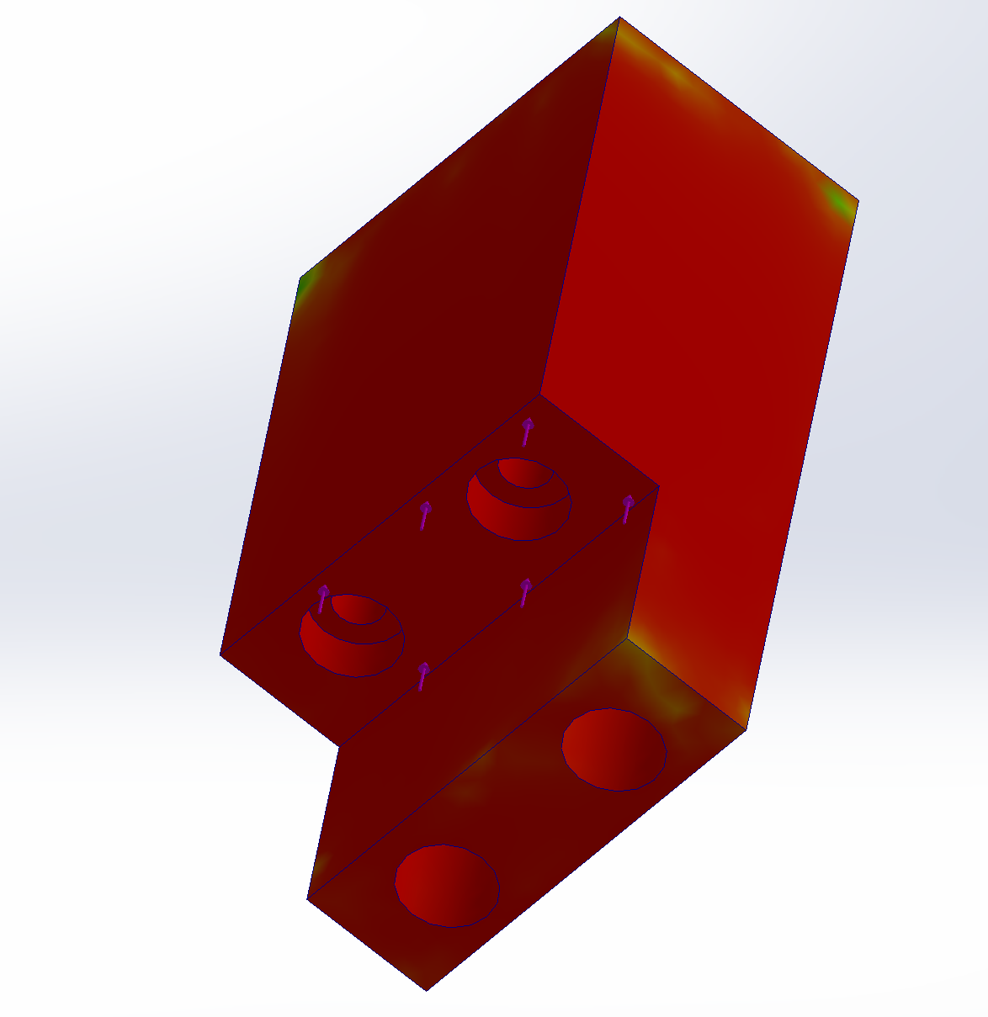
Figure 9 simulation for grippers
Additionally, we also designed the camera holders to attach the camera to the extrusion frame. We ran a simulation for it as well to make sure it is safe during operation. The force we used is calculated from the weight of the camera, which is 8.33N, acting on the drilled hole. The factor of safety is 222 for this simulation, which means it is safe to use this gripper design for our operation.

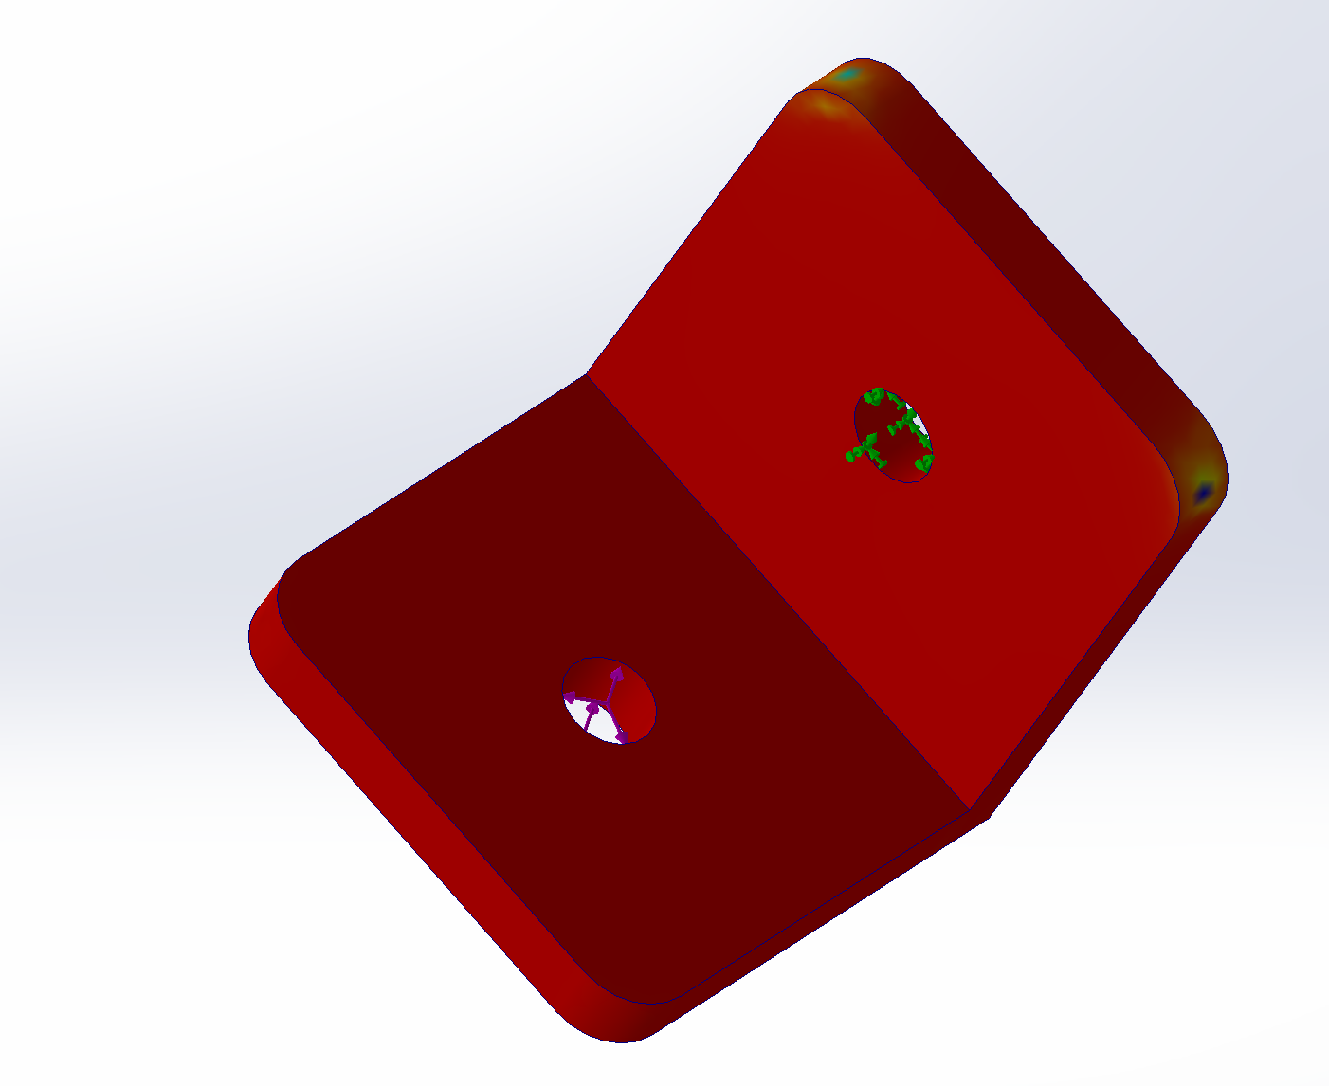
Figure 10 simulation for camera holder

Integration
The following results were achieved during the development of the integrated vision guided robotic system. These findings are based on prototyping conducted using an IRB120 and an IFM vision system camera by the team and include the following:
- Detailed procedures for each step of the project until completion
- Errors encountered and key observations throughout the process
- Concluding remarks on the project outcomes

3.1 Camera

3.1.1 Calibration
For camera calibration this will all be done within robot studio, if you do not have robot studio refer to 2.2.4 Vision Assistant.
Steps during camera calibration (Vision Assistant has a step-by-step process that we will recap)
- Once opening the IFM Vision Assistant you will click on Find sensor and find the O2U540

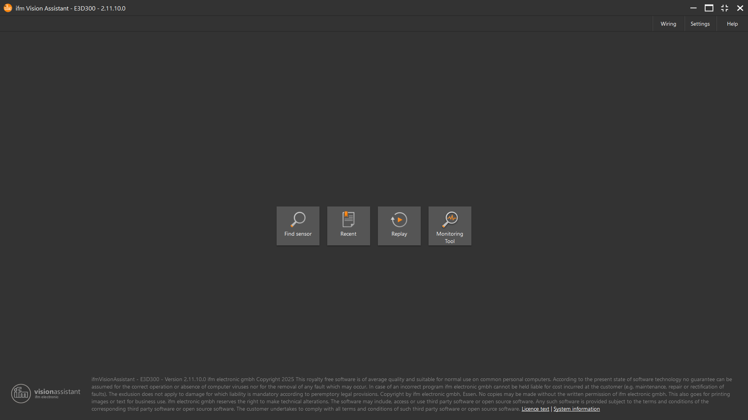
Figure 11 IFM Vision Assistant
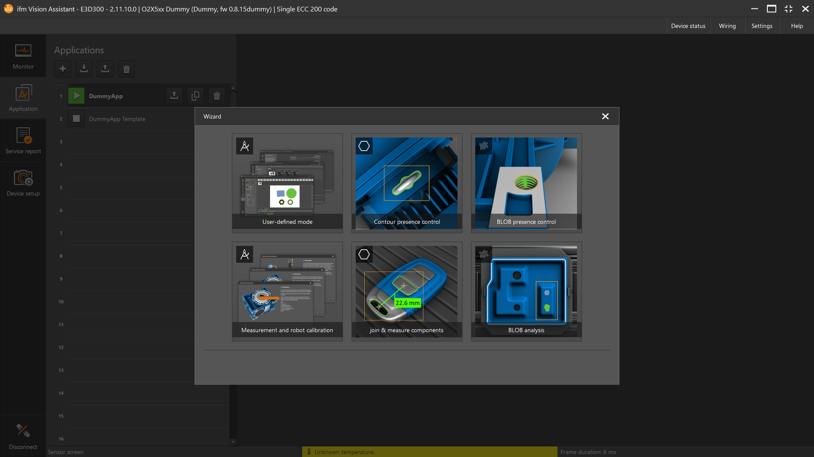
- Once in the IFM Vision Assistant navigate to the applications tab and click the + button and click on measurement and robot calibration
Figure 12 IFM application tab

- The Calibration wizard will open, you will choose robot sensor calibration, which will open the step-by-step window
- After determining the height of the camera, you can plug in that value into the distance in the section in the step 2 window or use the auto focus to find that value for you. The auto focus will not be as accurate as the real height.

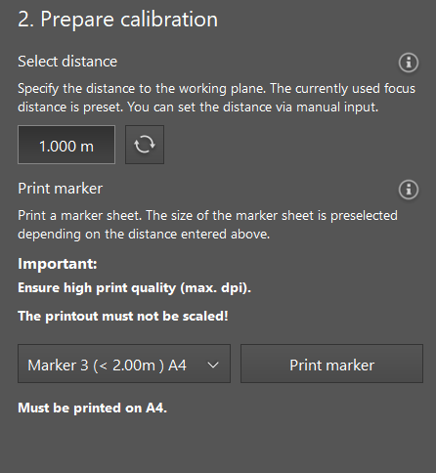
Figure 13 IFM calibration tab

- After the height is found you will print out a calibration sheet, depending on the height size the size of the paper changes. It is important when you print the sheet you choose the original size setting if you do not, the calibration will not work.
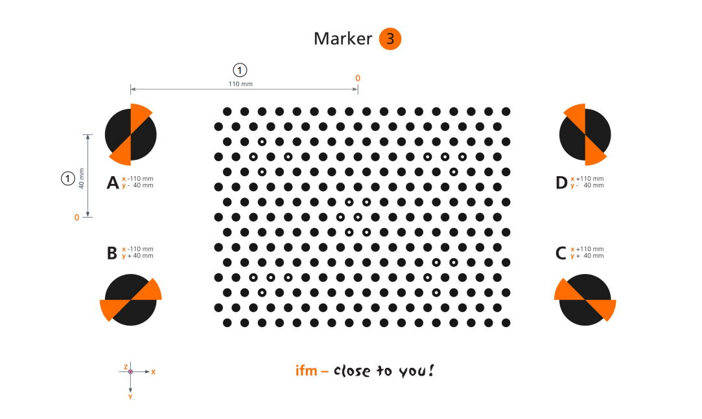
Figure 14 IFM calibration sheet
- After printing the sheet to size, you will place it in view of the camera. If you look in the bottom left corner, you will see an X and Y axis. You must orient the page in a way where the axis matches that of the IRB120.
- Once in the correct position you will focus the camera and adjust settings on the camera where you can see the dots clearly on the camera view. Illumination will be None because we are using external lighting.
- Once the sheet is in focus you will jog your robot to point A, B, C and D by placing the TCP in the center of the markers. Once the robot is in position you will input your X, Y, and Z coordinates, once you are finished click the Teach button.
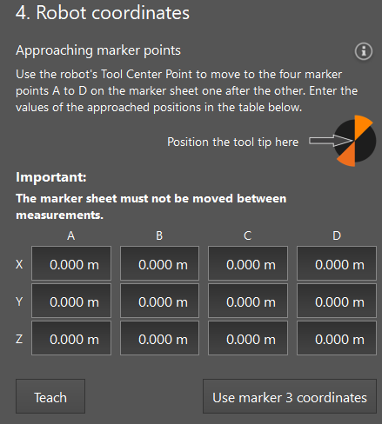
Figure 15 IFM robot coordinates tab

- Once this happens you will take multiple pictures to teach the camera. You will have the sheet in view and rotate it 4 times from the original position, move 4 times in the x or y coordination from the original position and tilt in the Z axis 4 times from the original position
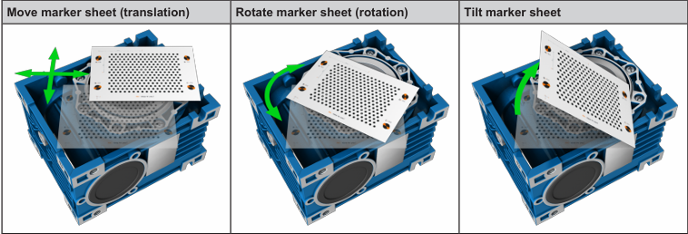
Figure 16 Marker sheet rotation examples
- Since we taught our sheet on the table, we calculated the Z offset of the bottom of the bin and input it into the
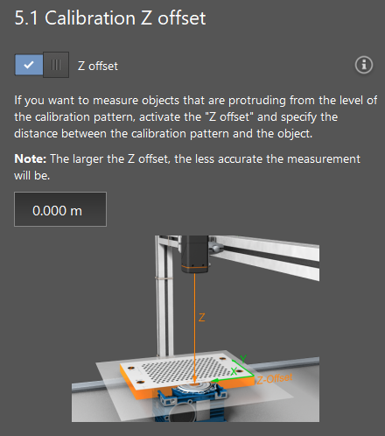
Figure 17 IFM Z offset calibration
- The last step is to test; there are measuring tools that you will use on the marker sheet to test how accurate your calibration was. Once you have confirmed that the calibration was accurate, you now have a coordinate system that the Camera and the Robot both understand.
During the camera calibration, we must consider the following:
- The work cell shall not move or vibrate as it can affect the accuracy of object detection during calibration.
- The lighting conditions may not be changed as any change in the light can affect the shadows and detection settings previously set.
- The focus of the camera must be adjusted to optimal visibility. It is recommended to use the automatic focus mode and then adjust it slightly with the manual setting to achieve the best results.
- During the calibration process, specifically in the stage involving repositioning of the calibration target, it is essential to capture images of the calibration sheet at multiple locations withing the camera’s field of view. While the total number of images should not exceed 15, we must ensure that a calibration score of at least 85% must be achieved to proceed to the subsequent steps.
- The calibration sheet must be printed on an A3 paper size, to scale to obtain the correct measurement during the calibration process.
- The X and Y direction of the calibration sheet must match the x and y coordinates of the Robot.

3.1.2 Models
When you are in an application or editing a previous application, you can add models to your application by going to the model’s tab on the left-hand side and clicking the +. 3 models were used, 1 Contour and 2 blob analyses. Before making the models, you will need to go to the images and trigger tab and alter setting until you can see the breaker in the bin effectively.
An Anchored contour was made for the breaker, the reason that it is an anchored contour is so that the next 2 models could be applied to the contour, so they are not trying to detect features inside the whole bin, just the breaker. The breaker was placed inside the bin and tape was applied to the bottom of the bin to create a bigger contrast between the two. The Contour tool will automatically make a Contour of the breaker that was edited to exclude unwanted features. In our application we removed the top and made it flat and removed the lock on the side of the breaker so that it can identify the back or face of the breaker. After refining the shape, the reference point was moved to the pickup point so that the X and Y Coordinate is calculated there instead of the center. In the parameters tab you can make the range of interests the whole bin and choose 1 object in the ROI so that it finds one breaker at a time. Finally, it is tolerance where you edit how off model it can be, and still identify it along with changing the max and min orientation to 180 to -180
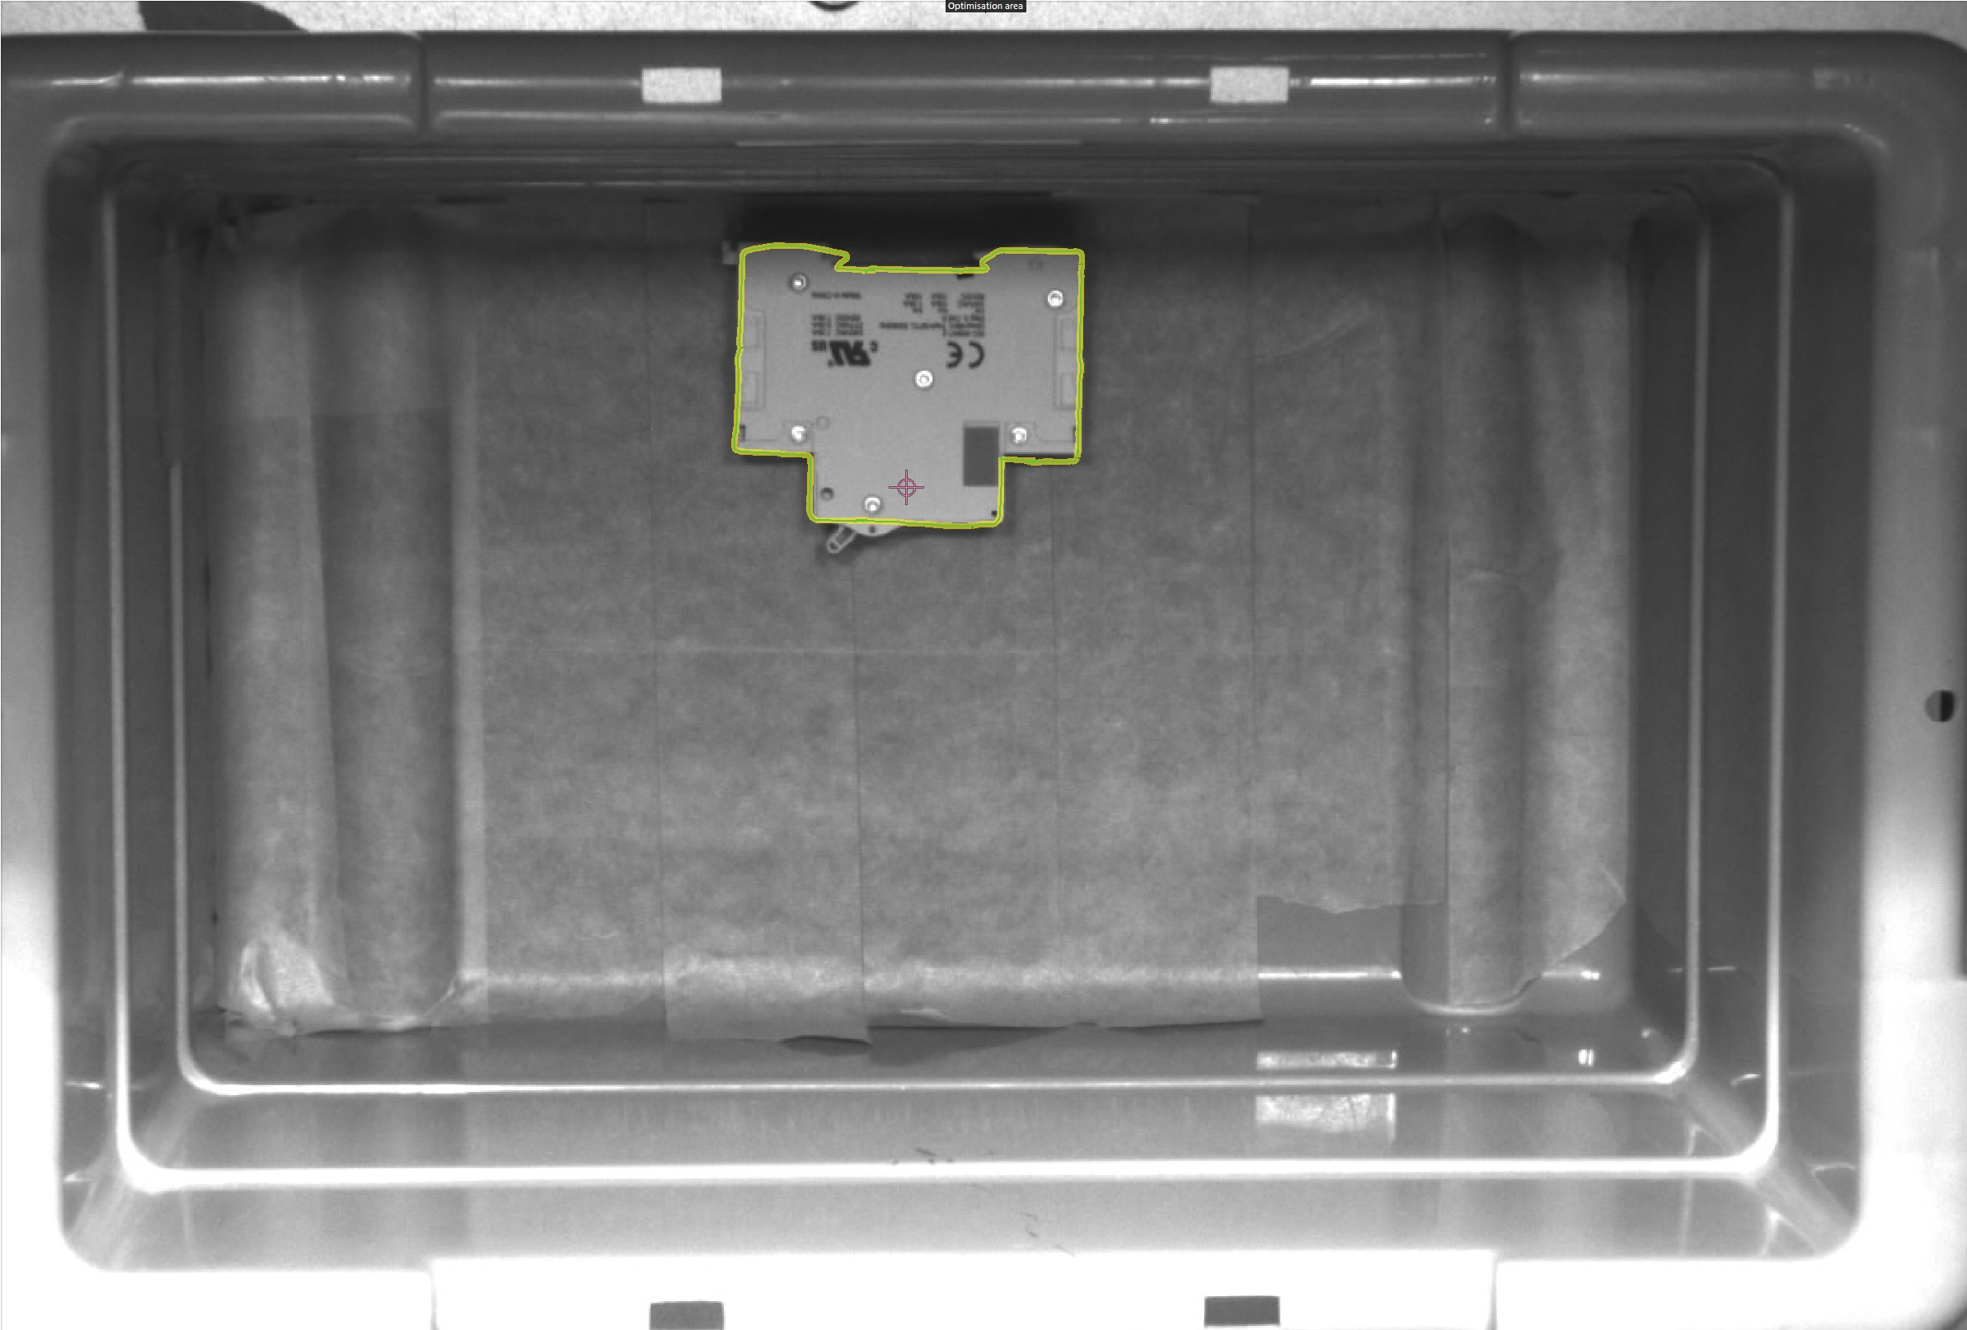
Figure 18 Anchored contour

The Blobs are created the same way, in model parameters you choose anchor tracking, then you edit the definition with the contrast until you can find the breaker within the bin. You can use a built-in tool to find the minimum and maximum greyscale to identify the breaker. For the second blob analysis, you will create 3 circles of ROIs. you will place these on the 3 screws on the breaker that form a 90-degree angle.
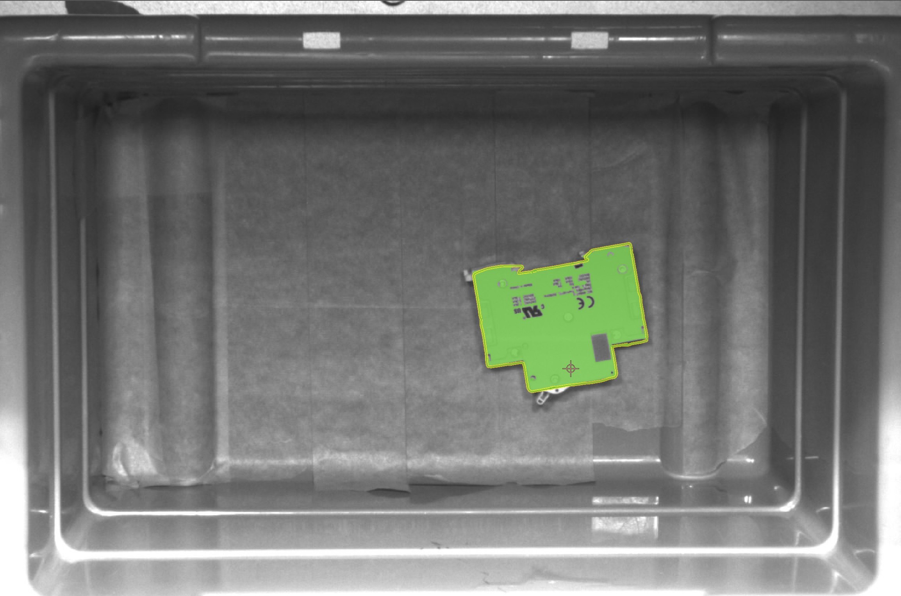
Figure 19 The Blobs analysis
The Contour identifies the part for the blob analyses, it will provide the coordinate of the breaker in the X and Y plane, and the rotation in the Z axis. The first blob is used to gain the change in the Z coordinate, identifying how high it is. The second blob is used to measure between the points and comparing those measurements to the actual size will give us the angle in the X and Y planes.

3.1.3 Logic and interfaces

The TCP/IP communication interface was configured using protocol Version 4 which is the recommended setting for machine-to-machine communication since it allows to transfer all the information needed to operate the camera and robot controller. The ticket length was set, where a ticket is a 4-digit identifier string attached to each message that is exchanged over the interface, allowing the controller to track and match requests with their corresponding responses. The interface was built on the preconfigured abb robot contour templated that was provided in the IFM vision assistant which streamlines the setup for ABB robot integration. Two parameters were customized from their defaults: the decimal precision of the transmitted coordinates values was reduced from 6 to 4 decimal places to simplify the data string without meaningful loss of positional accuracy, and the calibrated rotation angle was added as an additional field in the output of the string so that the orientation data could be transmitted alongside the positional coordinates to the robot controller
The logic was used to convert the number values from the information obtained and pack them on a string once converted and to apply the trigger function to send the data to the robot on a continuous way. This allowed that the information sent to the robot was always being live fed so that even while approaching it would still send data unless in the cases where ethe robot would block the camera that would just stay with the last data recorded
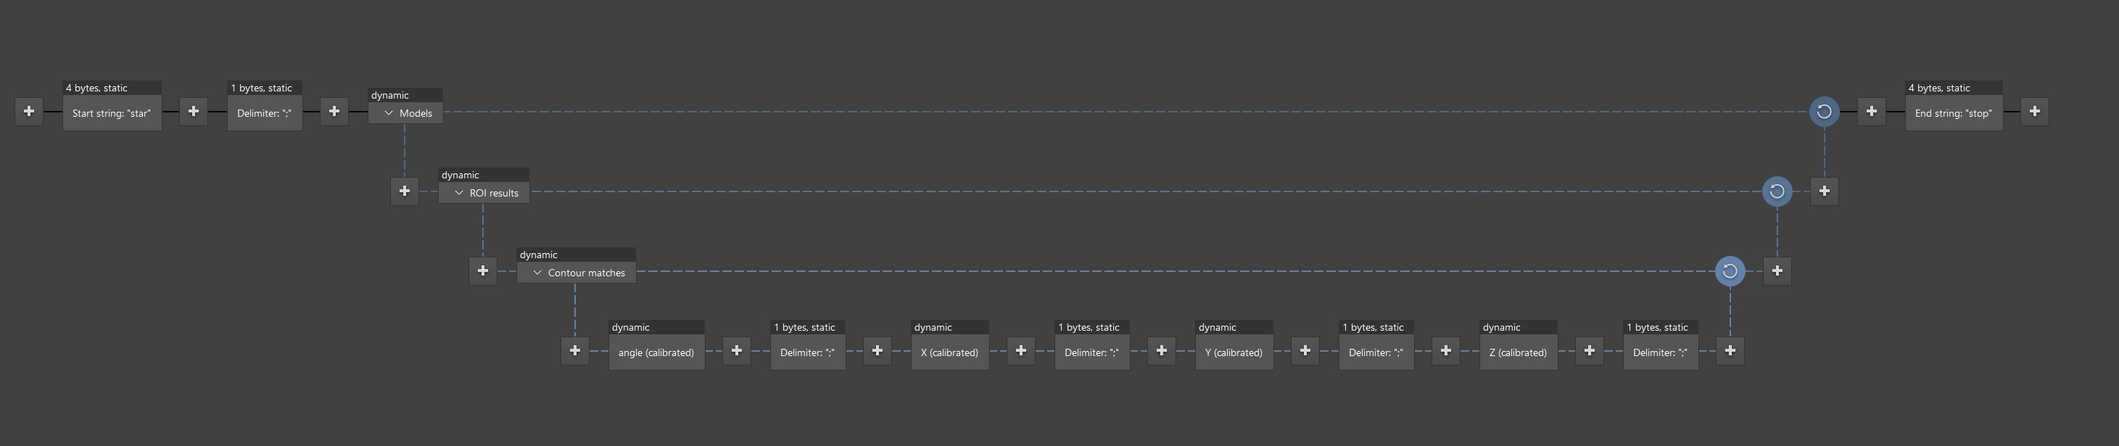
Figure 20 Interface

3.2 The integration of camera and robot
To properly integrate the camera and the robot it is necessary to add the camera IP address in the IRC5 Ethernet devices setting. Once this is done the integration and exchange of information between the robot and the vision camera happens through two stages:
- The I/O cables: through the cables and physical connection, the camera can send signals such as “object detected, picture obtained, etc. (this was not connected due to the IO entry ports were not configured during the process)

- TCP/IP: Via TCP/IP, the camera will communicate to the robot the position (Coordinate) of the circuit breaker detected, and thus the robot can ready this data, and pick up the circuit breakers as programmed to the robot controller through the routines.

3.3 The robot programming
The program is executed using Flex pendant, with the instructions processed in the robot controller. The program follows JSP standards and is organized into several routines for proper execution.
Since the gripper was changed, a new TCP had to be defined. To enable communication between the robot controller and the Camera, a TCP/IP connection is established using Socket commands. A portion of the implemented code is shown below:
SocketClose Client_socket;
Socketcreate Client_socket;
SocketConnect Client_socket;
SocketSend Client_socket\Str:=1;
SocketRecieve Client_socket\Str:=fine1;

The commands shown above first close any existing connections using Socketclose. A new communication channel is then established by creating and connecting to client_socket. Once the connection is successful, a signal is sent to the camera indicating that the robot is ready to receive data.
After the camera is triggered and processes the image, it sends the detected data to the robot, which is stored in the string variable fine1. This data is transmitted as a single string, with individual values separated by a semicolon ( ; ). At this stage, communication is successfully established, and the data has been received.
However, the received string cannot be used directly. Each coordinate must be extracted and assigned to separate variables so that the X, Y, and Z values can be used individually in the robot program. Initially, a string-splitting function such as StrSeperate would have been ideal, but this function does not exist in the IRC5 controller’s built-in library. As a result, a combination of StrFind and StrPart functions was used to manually parse the string. The code implementation for this process is shown below.

- Using only StrSeperate
Var String data {6};
StrSeperate fine1, “;”, Data; // data will be separated from string fine1, each semicolon and each piece will be stored in Data array.

- Using the combination of commands
VAR num Postion1;
VAR num Postion2;
VAR num Postion3;
VAR num Postion4;
VAR num Postion5;
VAR String SX;
VAR String SY;
VAR String SZ;
VAR String SA;

Position1:= Strfind (fine1, 1, “;”);
Position2:= Strfind (fine1, position1+1, “;”);
Position3:= Strfind (fine1, position2+1, “;”);
Position4:= Strfind (fine1, position3+1, “;”);
Position5:= Strfind (fine1, position4+1, “;”);
SX := StrPart (fine1, Position1+1, position2-position1-1);
SY := StrPart (fine1, Position2+1, position3-position2-1);
SZ := StrPart (fine1, Position3+1, position4-position3-1);
SA:= StrPart (fine1, Position4+1, position5-position4-1);

The program above separates the coordinate value from the string fine1 and stores them into individual string variables: SX, SY, SZ, and SA. However, these values are still in the string format and cannot be directly used for robot motions.
To utilize these values in the program, they must be converted into numerical data types. This can be achieved by using the StrToVal function, which converts each string into a num variable. The implementation of this conversion is shown below:

VAR bool SX1:= FALSE;
VAR bool SY1:= FALSE;
VAR bool SZ1:=FALSE;
VAR bool SA1:=FALSE;
VAR num SX2;
VAR num SY2;
VAR num SZ2;
VAR num SA2;

SX1:= StrToVal (SX, SX2);
SY1:= StrToVal (SY, SY2);
SZ1:= StrToVal (SZ, SZ2);
SA1:= StrToVal (SA, SA2);

After this step, the Variables SX2, SY2, SZ2, and SA2 are available as numeric data types, allowing them to be directly used in robot motion commands. It is important to note that these values are received in meters, while the robot operates in millimeters. Therefore, each value must be multiplied by 1000 before being applied. [2]
At this stage, the robot has all the required positional data and is ready to execute the pick and place routine. The following routine was selected for this operation.

1.VAR robtarget pabovebin;
2.VAR robtarget p1; // p1 is st at coordinates 0,0,0 so the offsets of it, will be the exact value on the coordinate.
3.VAR robtarget paboveDIN; //this place is above the DIN rail and is a bit offseted from the center of the rail.
4. VAR robtarget pDIN;

5.MoveJ pabovebin, v10, fine, newtcpvisonick;
6.rRelease;
7.MoveL Offs (p1, SX2 * 1000, SY2 * 1000, SZ12 * 1000), v10, fine, newtcpvisonick;
8.rPick;
9.MovL pabovebin, v10, fine, newtcpvisonick;
10.MoveL paboveDIN, v10, fine, newtcpvisonick;
11.MoveL pDIN, v10, fine, newtcpvisonick;
12.rRelease;
13.MoveL paboveDIN, v10, fine, newtcpvisonick;

The team has faced difficulties at line 7 in the above program, where the robot moved to a position different from the expected location of the circuit breakers. Although the coordinates displayed on the robot's jogging menu matched those provided by the camera, a misalignment was still observed. This issue can be caused by several reasons.
One possible cause is robot configuration. While the robot is aware of the target pick position, the use of a 2d camera limits the available information to only x and y coordinates. Without orientation data, the robot cannot accurately determine the correct approach angle required to pick up the circuit breaker.
Another contributing factor is camera calibration. It is essential that the X and Y axes of the calibration grid align precisely with the robot’s coordinate system. Any mismatch between the axes can result in incorrect positional data.
Additionally, the camera was positioned at an angle to ensure a clear field of view, avoiding interference from surrounding objects. However, this setup introduced errors during calibration, which in turn affected the accuracy of the recorded coordinates.
Finally, when defining the TCP, any offset from the true center of the tool must be carefully considered. In this case, the dimensions of the calibration cone introduced offsets that needed to be accounted for in the X, Y, and Z directions. [5]

Unfortunately, at this time, the team will not have enough time to finish the project but below is a list of solutions to all the problems led to unfinished work.
To solve the robot configuration issue:

To resolve the calibration issues, the team would recalibrate the camera. During this process, it is essential to ensure that the correct tool is selected, as this directly affects the accuracy of the calibration. Additionally, the calibration sheet must be properly aligned with the robot’s X and Y axes to maintain consistency between camera and robot coordinate systems.

It is also important to keep the camera fixed in position, as any movement after and/or during calibration could introduce further errors. To address the issues caused by the camera’s angles position, the team would modify the mounting brackets to increase the distance between the camera and the structure. These adjustments would allow the camera to be positioned more directly above the bin, eliminating the need for an angle and improving calibration accuracy.

Performing a load to identify is recommended to improve the robot’s motion accuracy.
Furthermore, when defining the TCP, the dimensions of the calibration cone need to be carefully considered to account for any offsets from the tool’s true center.

To use the IFM O2U540 as a 3D identifier the positional data obtained from the vision sensor could have been extended to analyze the full 3D orientation of each circuit breaker. The given sensor provides x, y, z coordinates along with rotation angle in the z axis. To acquire the remaining angles, three of the holes that the breakers have on the surface that form a 90-degree angle could be used as reference points. By measuring the distances between these three points and comparing them to the known real-world dimensions of the breaker, the tilt of the breaker in x and y planes or also known as roll and pitch, could be calculated. This would be achieved by doing a rotation matrix from the tree derived angles, which would eventually be transformed into Rx, Ry, Rz values needed by the robot.[1]

3.4 Additional information on the project
In addition to the main steps of the project, several enhancements were implemented to improve overall system performance.
A set of lights was added to the work cell to address the camera’s sensitivity to the lighting conditions. To compensate for potential variations in light levels and ensure consistent detection, external lighting was installed to supplement the existing illumination.
As requested by the client, an external power supply was used for the camera instead of directly connecting to the controller. This approach eliminates the risk of high-voltage inference from the controller affecting the camera. The power supply was mounted on the aluminum extrusion above the work cell to prevent any potential damage from placement at lower levels.

4. Conclusion
The Vision Pick project successfully demonstrated the design and partial implementation of a vision-guided robotic pick and place system for handling circuit breakers. The system integrated the O2U540 camera from IFM, ABB IRB120 robotic arm, custom brackets to hold the camera, and a custom-made end effector that was able to pick any part of the breaker. The camera was able to effectively detect the position and orientation of the breaker, but only when the breaker was fully exposed. The communication between the camera and robot was established using ethernet based TCP/IP protocols.
Through the project most of the necessary phases to achieve a full completed project were succeeded. The development process highlighted the importance of proper calibration, consistent lighting conditions and the most important, proper alignment between the vision and robotic coordinate systems. Challenges faced during implementation, particularly related to positional accuracy and system calibration, provided extremely important insight into the limitations of 2D vision systems and how essential is the consistency of the environment that the system is being set up.
Although the system was not completed to the desired final product within the given timeframe, the work completed demonstrates a functional approach to solving bin- picking problems using 2D vision systems and robotic arms. The project also recognized clear paths for improvement, including refining calibration procedures, improving camera positioning, and choosing a proper set of lights.
Overall, the system shows strong potential as a flexible and cost-efficient solution for automated material handling applications. The knowledge and experience gained throughout this project contributes to a deeper understanding of how vision systems are implemented in other systems, how communication protocols affect even hardware decisions and how real-world automation challenges are a level above any practice in a controlled atmosphere like school.

Bibliography

[1] | A. I. 1. Robot, "ABB IRB 120 Robot," robots.com and tie brand, [Online]. Available: https://www.robots.com/industrial-robots/abb-irb-120.
[2] | J. Bauer, Youtube, Oct 2025. [Online]. Available: https://www.youtube.com/watch?v=UQqsvaHzIRc. [Accessed March 2026].
[3] | "Product specification - IRB 120," [Online]. Available: https://library.e.abb.com/public/6aed5e91083f4fceb358eea2fe4c1bab/3HAC035960%20PS%20IRB%20120-en.pdf?x-sign=edIex5StIjpgmJBJJ95tak9NHdyuuut6mzzJHESGKt5i1JG8dhLRBdvggKptgBJn.
[4] | "ABB robotics: compact industrial robot controller," 13 mar 2015. [Online]. Available: https://www.packworld.com/secondary-packaging/robotics/press-release/13367260/abb-robotics-compact-industrial-robot-controller.
[5] | D. Arigato, "Robotics," 23 Oct 2022. [Online]. Available: https://robotics.stackexchange.com/questions/23935/how-do-i-convert-a-set-of-coordinate-and-rotation-values. [Accessed 10 April 2026].
[6] | "FlexPendant User Manual for Robotics," ABB, [Online]. Available: https://www.scribd.com/document/873586334/3HAC093167-PM-FlexPendant-En-RevA. [Accessed 01 04 2026].

Appendices

Robot additional information:
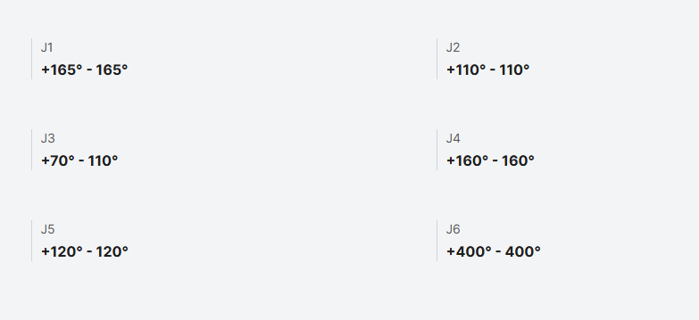
Figure 21 Robot's working range
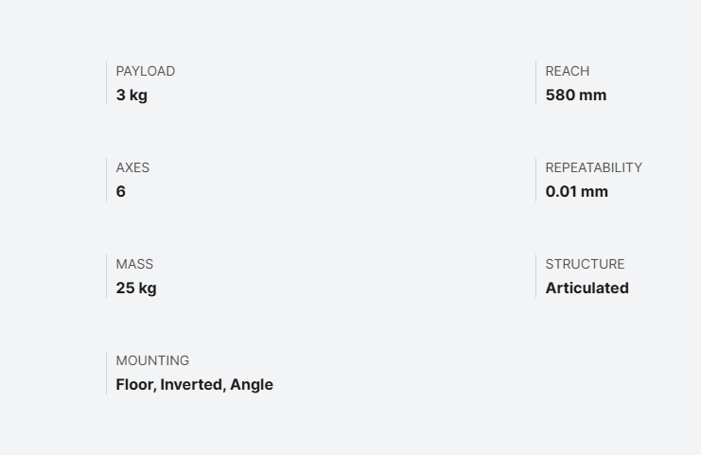
Figure 22 Robot specification

Client agreement

Figure 23 Client agreement
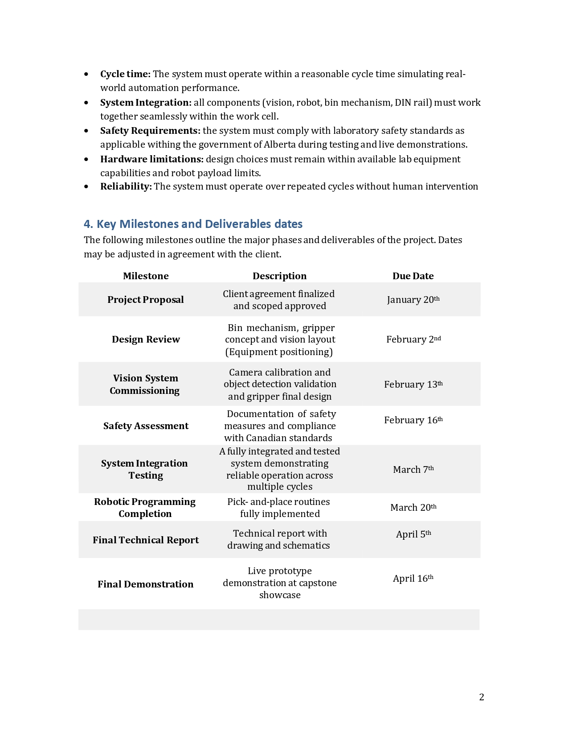
Figure 24 Milestones and due dates

Figure 25 Signatures

Management
The team was split into two groups, Team camera and Team Robot. Even though everyone tried to read and understand most of the process while creating this system, the decision to splitting the team was key to being able to achieve all the important findings that were discovered.

Relevant findings
- Integration and calibration: the robot and camera should share the same coordinate system by using the calibration sheet. Work-cell should not vibrate to be able to detect objects accurately.
- Camera performance: the camera should be mounted at approximately 2m to capture the whole bin. If there is shadow, the detection will not be accurate. Additional lights should be used to prevent that. 2D cameras can only provide x and y coordinates, whereas bin picking requires orientation data to pick up the circuit breakers correctly.
- Communication: data provided by camera to robot is string data, robot needs code to separate string to smaller parts and converted to numbers to use it as coordinates.

Discussions
Our team has been successful in integrating communication between the IFM camera and ABB robots using TCP/IP protocols. Therefore, the robot can identify random orientation of circuit breakers to do pick and place process. However, the camera data lack of z-axis orientation makes it challenging for the robot to know the angle to pick up. We also learned that we need to calibrate the vision system precisely, we must use tool center point when doing it, so the camera knows exactly the coordinates of robot arm, thus gives accurate coordinates to the robot. This knowledge is very useful for us to use in the future if we work with vision system again.

Safety assessment
- Operational safety
- Personnel who perform operations, maintenance, or repair must be trained to ensure safety procedures are followed.
- If the operators must access the work-cell while the robot is working, manual mode can be used with the flex pendant being always held.
- The flex pendant has a three-stage enabling button so that the operators must hold while the robot is moving in manual mode. The operators must hold this button at the center position to enable the robot. If the button is not pressed or is pressed past the center position, the robot will stop immediately. [6]
- The camera should be positioned consistently at the designated position or maintained at the same height to ensure a full view of the bin.

- Safeguards and PPE
- Robot work-cell is provided to ensure operators do not accidentally touch the robot while it's working.
- Emergency stop buttons are available on both the flex pendant and controller, allow the operators to stop the robot immediately in case of emergency.
- Safety glasses must be always worn when working with robot systems, compressed air, or electrical equipment.
- Safety interlock switches are installed on all doors of the work-cell which stop the robot if operators try to open the door while the robot is working in automatic mode.
- Work-cell doors must be closed to use the robot in automatic mode.
- Environmental safety
- The work environment should be kept clean, with minimal amount of dust or debris, as contaminants on the camera lens can reduce system accuracy.
- IRB120 is a clean room robot, which must be operated in a clean room environment, according to ISO 14644-1. [3]
- The maximum load capacity for the end effector of the robot is 3kg, and 0.3kg for upper arm mounting. [3]
- Robots cannot be operated in an explosive environment. [3]
- The robot must be warmed up before running if operating temperature <10° C. [3]
- Maintenance and hazard prevention
- Only trained personnel are allowed to install, maintain, and repair the camera and robot system.
- Ensure there is no obstacle within the robot work envelope.
- The surface of the controller might get hot during operation, which can cause burning.
- Ensure there is no sign of loose wires.
- Ensure that wires are organized.
- Regularly check wire conditions, make sure there is no damage to the wires.
- Camera not working: the operators must stop the robot immediately if the camera freezes or frame drops. Robots running when vision loss may cause damage or collision.
- Do not touch the halogen lights after turning on; the surface can get very hot. Always check the lights temperature before doing maintenance.
- Always shut off the air pressure system before unplugging the air hose. High air pressure can cause body damage.

